Common Cooking Vocabulary #2
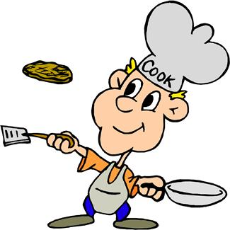
boil  bread  broil  brown | cube  dice  grill  grind | mince  mix  peel  simmer | stew  stir fry  toast  whip

__________ | - To stir ingredients together with a spoon, fork, or mixer until well combined
__________ | - To cook in liquid that is just below the boiling point.
__________ | - To cook by direct heat, under a broiler or over hot coals.
__________ | - To brown with dry heat in an oven or toaster.
__________ | - To cut into to very small pieces, smaller than chopped or diced pieces
__________ | - To simmer slowly in enough liquid to cover.
__________ | - To heat a liquid to the point that bubbles break continuously on the surface.
__________ | - To cook on a rack over hot coals or other direct heat source that simulates coals.
__________ | - To reduce a food to fine particles using a blender or food processor.
__________ | - To coat with flour, then dip into beaten egg or milk, then coat with crumbs from crushed stale bread, cereal or crackers.
__________ | - To cook over medium or high heat until surface of food browns or darkens
__________ | - To pull away, strip or cut off the outer covering of a fruit or vegetable.
__________ | - To beat rapidly with a wire whisk, or mixer to lighten and increase volume.
__________ | - To cut into small squares of 1/8" to 1/4".
__________ | - To cook in a frying pan or wok over high heat in a small amount of fat, stirring constantly.
__________ | - To cut a solid food into squares of about 1/2" in size or larger.

Answer Key
Note: The answer key could be cut into strips and used as a matching exercise.
mix | To stir ingredients together with a spoon, fork, or mixer until well combined
simmer | To cook in liquid that is just below the boiling point.
broil | To cook by direct heat, under a broiler or over hot coals.
toast | To brown with dry heat in an oven or toaster.
mince | To cut into to very small pieces, smaller than chopped or diced pieces
stew | To simmer slowly in enough liquid to cover.
boil | To heat a liquid to the point that bubbles break continuously on the surface.
grill | To cook on a rack over hot coals or other direct heat source that simulates coals.
grind | To reduce a food to fine particles using a blender or food processor.
bread | To coat with flour, then dip into beaten egg or milk, then coat with crumbs from crushed stale bread, cereal or crackers.
brown | To cook over medium or high heat until surface of food browns or darkens
peel | To pull away, strip or cut off the outer covering of a fruit or vegetable.
whip | To beat rapidly with a wire whisk, or mixer to lighten and increase volume.
dice | To cut into small squares of 1/8" to 1/4".
stir fry | To cook in a frying pan or wok over high heat in a small amount of fat, stirring constantly.
cube | To cut a solid food into squares of about 1/2" in size or larger.

