The Guardian
http://www.guardian.co.uk/lifeandstyle/wordofmouth/2012/dec/18/tv-chefs-food-not-unhealthy

Hugh Fearnley-Whittingstall: TV chefs' food isn't unhealthy
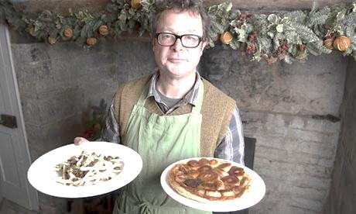
Research suggests that ready-meals are healthier than those of many celebrity chefs. But that's mainly down to smaller portion sizes.

Larger portions, but still healthy: Hugh Fearnley-Whittingstall with some of his dishes. Photograph: Rex Features
The media have made a hearty meal of research from the British Medical Journal revealing that some of us who cook on telly have published recipes that compare unfavourably for fat and calories with supermarket ready-meals.
Reading between the lines, it seems that portion control is the culprit. You tend to get a lot more food on your plate with a celebrity cookbook recipe than with a supermarket ready-meal. Divide the quantity of ingredients by the number of people the recipe serves, and of course a more generous serving means more calories per portion. You can see how this difference comes about: I guess the cardinal sin for a chef/home cook/host is to be thought mean. In the supermarket, by contrast, parsimony equals profit.
Nonetheless, I take the study as fair warning that I should be careful to practise what I preach – or at least not to practice what I preach against. Intrinsic to the job of cookery writer and TV chef is encouraging people to cook more, and depend less on ready-meals and takeaways. And we are generally promising, or at least implying, that our readers and viewers will have not just a happier but a healthier relationship with food if they do. So what responsibilities does that leave us with?
Good food, and a healthy diet, is about variety and balance – and I think those of us who cook on television and publish cookbooks should uphold those fundamental pillars of sound nutrition. But that applies across the whole spectrum of our recipes. It doesn't necessarily mean we should count all the calories in our recipes and strain to reduce fat at every opportunity.
Deliciousness, originality and excitement are what we are striving for. You can achieve that in recipes that are intended to be hearty main courses or comforting supper dishes, and you can achieve it in original salads that are bursting with fresh, crisp, raw vegetables and fruit. The balance comes in offering readers and viewers a tempting cross-section of all these kinds of dishes. What we can't do is control which recipes our followers choose to cook, and which to ignore. We can only encourage a balanced approach by ensuring there is deliciousness right across the menu.
One thing I am constantly striving for, especially in my two most recent books, is to make healthy recipes more tempting. It's a mission I'll be carrying through to my next book with extra zeal.
ACTIVITIES

- Useful vocab:
ready-meals | culprit | host | strive for
practise what you preach | takeaways | fat | cross-section
strain to reduce | carry through | zeal | crisp

- Comprehension questions:
- What seems to be the problem when we compare ready-meals from supermarkets and TV chefs’ recipes?

- What do chefs feel responsible for (paragraphs 2 and 3)?

- But can chefs really guarantee that we, the consumers, follow a healthy diet? What can they (or cannot) do?

- Hugh has written two books recently. What is his main goal?

- Speaking time – Debate:
- Do you agree with Hugh’s point of view on diets, health, recipes and ready-meals from supermarkets or takeaways? Why (or why not)?
- Do you cook at home? If you do, how often? Which are your favourite recipes? Who taught you to cook?
- Do you order takeaways or buy ready-meals from your supermarket? If you do, how often? Do you like them? Do you prefer home-made food or fast food?
- When you travel abroad, what do you do? Do you usually go to a fast food restaurant or do you feel adventurous enough and taste the local cooking? If you prefer the latter, what is the weirdest thing you’ve ever tasted in your entire life? Tell us your experience.

