**Find the hidden words within the grid of letters. Then use the leftover letters to find the hidden message.**





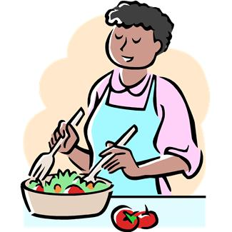

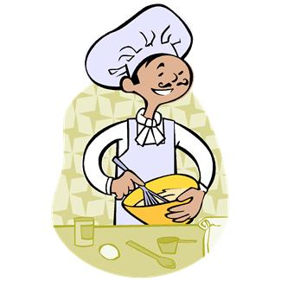





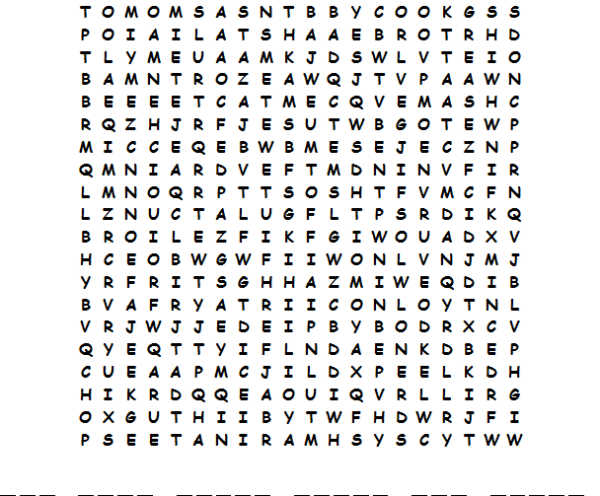

|  |  |  |  |  |  |
| --- | --- | --- | --- | --- | --- |
| **bake**  **baste**  **beat**  **blend**  **boil**  **bread** | **broil**  **brown**  **chop**  **cream**  **cube**  **dice** | **drain**  **fillet**  **grate**  **grease**  **grill**  **grind** | **knead**  **marinate**  **mash**  **mince**  **mix**  **peel** | **preheat**  **sauté**  **shred**  **simmer**  **steam**  **stew** | **stir fry**  **toast**  **whip** |

**Find the hidden words within the grid of letters. Then use the leftover letters to find the hidden message.**















|  |  |  |  |  |  |
| --- | --- | --- | --- | --- | --- |
|  |  |  |  |  |  |

**Answer Key**

