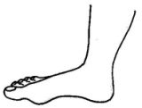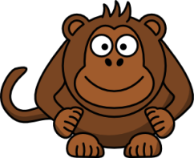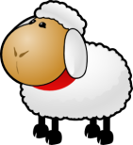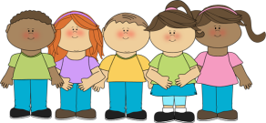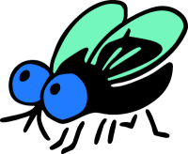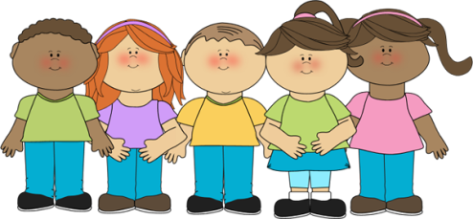

**Choose the right option:**

1. I had two _____________ for lunch today. a) applees b) apple c) apples

2. I was scared because John brought 2 ___________ to school. a) knifes b) knive c) knives

3. My favourite MacDo meal is a Big Mac with _________. a) fryes c) frys c)fries

4. In my family there are more _________ than females. a) mails b) males c) malls

5. New Zealand has a lot of ____________. a) ships b) sheeps c) sheep

6. There are many __________ here. a) flys b) flies c) flyes

7. We always have ____________ for dinner. a) potatoes b) potatos c) potato

8. We caught a lot of ___________ yesterday. a) fishes b) fishs c) fish

9. My mother is afraid of ____________ a) mice b) mouses c) mouths

10. It is only for __________. a) mans b) man c) men

11. In my class there are many ___________. a) children b) childs c) chills

12. Do you know where my __________ are? a) keyes b) keys c) keies

13. There were 12 ________ in the tray. a) egges b) egg c) eggs

14. I like ____________. They are so funny to watch. a) monkies b) monkeys c) monkeyes

15. You have lips like ___________. a) cherryes b) cherries c) cheerys

16. It is normal to have 28 ___________. a) tooths b) teethes c) teeth

17. There are three ____________. a) dice b) die c) dices

18. How many ____________ did you take at the party? a) photoes b) photos c) photo

19. We bought three ________ for dinner. a) salmones b) salmon c) salmons

20. Do you know where the __________ were from? a) thieves b) thiefs d) thiefes

21. Both my _________ are sore. a) foots b) feet c) feeds

22. Out of seventeen students three became __________. a) cheves b) chefs c) cook

23. In my class there are 9 girls and 10 _________. a) boys b) boyes c) boies

24. I love _________. They are nice when it is hot. a) tries b)trees c)threes

25. ________ are wiser than men. a) womans b) wimen c) women

26. A lot of the kids had __________. a) lice b) lices c) lies