Name: | Class: | Date:
Grammar: Irregular Plural Nouns
Complete the sentences with the plural form of the nouns in red:

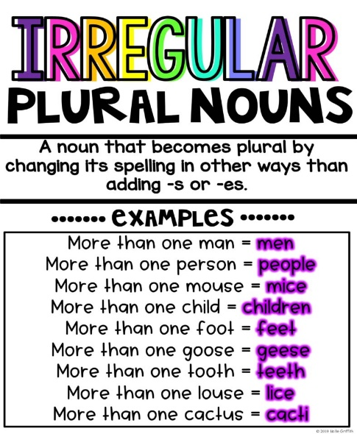
1. Only six ______ are allowed in this lift. (person)
2. Can you cut the lemon into two _______? (half)
3. I bought three _______ from the market. (fish)
4. Our ________ played happily in the park. (child)
5. The lamb was attacked by a pack of ______. (wolf)
6. Don’t forget to brush your ________ . (tooth)
7. Many ________ love to go shopping. (woman)
8. Be careful! Those ______ look really sharp. (knife)
9. People have one life, cats have nine ________. (life)
10. We need two ________ to make sandwiches for the picnic. (loaf)
11. The ___________ were caught by the police yesterday morning. (thief)
12. Look at your ___________ they are filthy. (foot)
13. Jill’s cats love to chase and catch ____________ in our alleyway. (mouse)
14. The _______________ got together to watch the football match. (man)
15. My mother loves wearing ___________ around her neck. (scarf)
16. I saw a flock of ___________ flying over our house. (goose)
17. I had to brush up all the dead ___________ in our garden. (leaf)
18. The horse’s _____________ need cleaning . (hoof)
19. In the past farmers used __________ to help plough the fields. (ox)
20. We have to go to IKEA to buy a few ________ for all your books. (shelf)
21. Alice often saw __________ in the hours of the morning. (deer)
Exercise: Use any of these irregular plural nouns in your own sentences.

