Chop Suey and Chow Mein
What could symbolize Chinese cooking more than chop suey and chow mein? Even people who steer away from more exotic Asian fare have enjoyed these two dishes at one time or another.
What goes into making these two popular restaurant dishes? Both are stir-fries; while chop suey consists of vegetables and meat with a gravy, chow mein is a fried noodle dish. Chow mein noodles are normally made with wheat flour, egg and water – the noodles can be softer or crisper, depending on how long they are fried.
Italian pastas such as fettuccine or linguine make a good substitute if you don't have Chinese egg noodles on hand. Both chow mein and chop suey normally contain chicken or meat, although there are also seafood and vegetarian versions.

Does Either Represent Authentic Chinese Cuisine?
Of the two, chow mein is considered to be the more authentic Chinese dish.
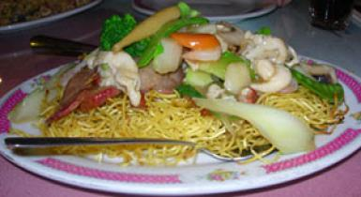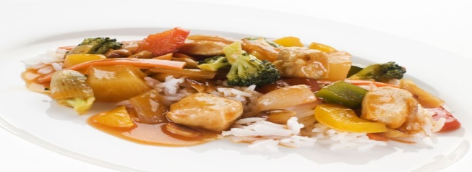
Chow Mein (Chinese-authentic)
Chop Suey (American-styled)

Food historians generally agree that chop suey as we know it was invented in the United States in the mid-1800's, possibly by one of the Cantonese immigrants who flooded California searching for work. Constrained by the lack of Asian vegetables, and trying to produce a Chinese dish palatable to westerners, a Cantonese cook stir-fried whatever vegetables were handy, added some meat or chicken, and served the finished product on a plate of steamed rice. He christened his creation, chop suey, which is the English pronunciation of the Cantonese words "tsap seui" ("tsa-sui" in Mandarin) which means "mixed pieces".
A variation of the story credits a Japanese chef with inventing chop suey in an effort to appease a visiting general.
As it was too late in the evening to prepare a proper meal, the chef simply threw together some leftovers and chop suey was born. In this version the dish was originally called Lee Gone Chop Suey, named after General Lee Hon Chung, the man who inspired its creation.
Entertaining as these stories are, the origins of chop suey may actually lie in the countryside of southern China.
According to anthropologist E.N. Anderson, the idea of combining leftover vegetables and noodles into a single, stir-fried dish originated in Toisan, a rural area south of Canton. Since many of the original immigrants to the United States were from this region, they naturally prepared the type of food they were familiar with.
The historical background of chow mein is far less mysterious. Ciao Mein or "fried noodles" originated in Northern China. While the chow mein served at take-outs and many American Chinese restaurants is designed to appeal to western tastes, it is based on an authentic Chinese dish. Until recently, our perceptions of Chinese food were based on early Chinese immigrants, who came primarily from the Canton (Guangzhou) region in southern China. Since they ate rice, we assumed all Chinese eat rice. However, wheat and not rice is the staple crop in the north. So, in a way you can say that chop suey and chow mein represent northern and southern styles of Chinese cooking.

In the Kitchen
Besides being easy to make, both these dishes are very adaptable. Like all Chinese food, what makes chop suey and chow mein memorable is not the specific ingredients so much as the balance between grains and vegetables. I often make them when I want to clean out the refrigerator before the vegetables go stale.
While it's preferable to have a wok, both these dishes can be made in the frying pan. And don't be afraid to make substitutions if you don't have all the ingredients called for in a particular recipe. One final tip: don't make both dishes on the same night - you'll be eating leftovers for the next week!
Questions
- Explain all the italics words or phrases. (There are 25).
- Does Chow Mein and Chop Suey both normally have meat in them?
- What was the main reason for Chop Suey being created?
- Why is Chop Suey considered a Southern-styled dish?
- Which dish is the more commonly eaten in Western societies?

