Bribing children to behave

Some call it a treat, as when a child is promised dessert if she finishes her Brussels sprouts. Others call it a reward, such as purchasing a video game for doing well on a test. Whatever innocuous terminology the action may be dressed in, though, promises of desserts, toys, or favors are actually bribes. What's worse, many parents readily admit to caving in to their kids, buying what previous generations simply demanded as appropriate behavior.
Parenting experts agree that rewards have a time and a place. But some parents have gone overboard. They pay their children to brush their teeth, go to sleep at an appropriate time, or even score a few goals at a soccer tournament! Although it may achieve results in the short term, it can lead children to become adults with unrealistic expectations of how the world works. There grows a sense of "What are you going to give me?"
In part, bribing our children to behave stems from the modern world, because past generations didn't have as many material goods to offer their kids. Parents are now busier than ever before, too, with both mom and dad juggling careers and parenting duties. Frazzled, overworked, and overtired, many admit that they don't want another power struggle. With each bribe, children up the ante. They demand more and more.
Of course, it's completely unrealistic to assume parents will never reward their children from time to time. The action should strike a balance and equal the reward, though. It should also be used sparingly. Parents instead should emphasize that it's rewarding enough to do the thing. For example, going to bed early will ensure that you feel well rested tomorrow. If that doesn't work, there's nothing wrong with saying, "Because I said so!"

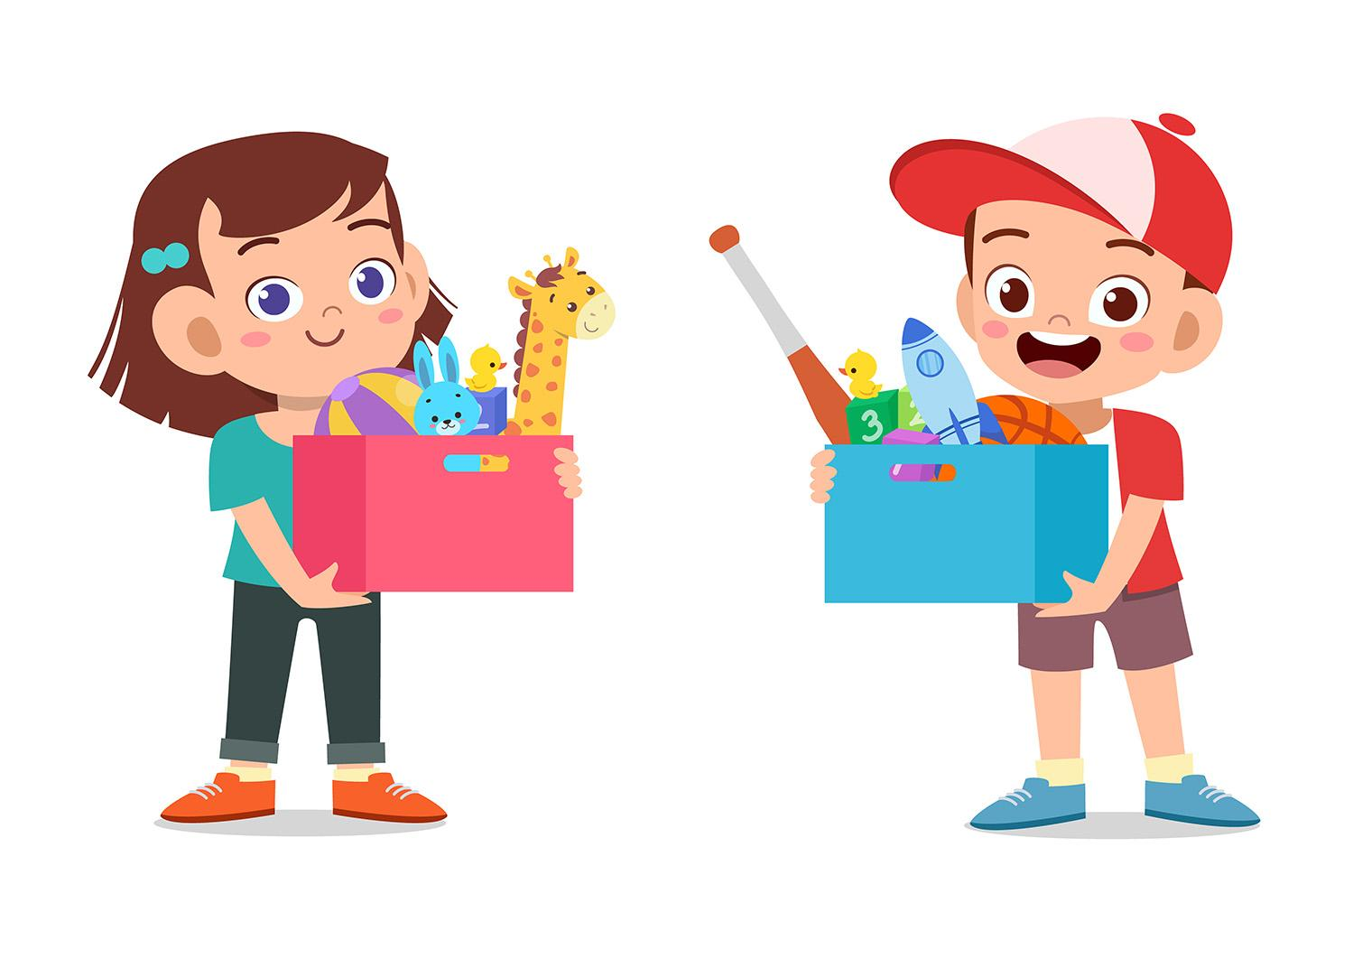

I. Exercise one - Fill in the blanks

1. Some call it a __________________________________.
a. punishment
b. reward
c. trick
d. treat

2. Parents are now __________________________________ than ever before
a. happier
b. busier
c. angrier
d. content

3 . __________________________________ instead should emphasize that it's rewarding enough to do the thing
a. Children
b. Parents
c. Adults
d. Siblings

II. Exercise two - Answer the questions

1. What does innocuous mean?

________________________________________________________________

2. What is a bribe?

________________________________________________________________

3. Why do parents bribe their children?

________________________________________________________________

4. What does frazzled mean?

________________________________________________________________

5. What are some of the ways that parents bribe their children to behave?

________________________________________________________________

III. Exercise three - Talk about yourself

1. Do you think parents should bribe their children to behave?
____________________________________________________________________________

____________________________________________________________________________

2. Were you ever bribed to behave well as a child?
____________________________________________________________________________

____________________________________________________________________________

3. What do you think a good bribe should be for children?
____________________________________________________________________________

____________________________________________________________________________

This is a free worksheet for your ESL lessons from
JIMMYESL.com
………...
Get more free resources here
https://jimmyesl.com/esl-teacher-resources/
…………
For questions, comments or just to say “thank you”,
send an email to ESL Teacher Jon Race at
jon@team.jimmyesl.com

Simply print out this worksheet
without the last page
for your lessons.

