Global warming

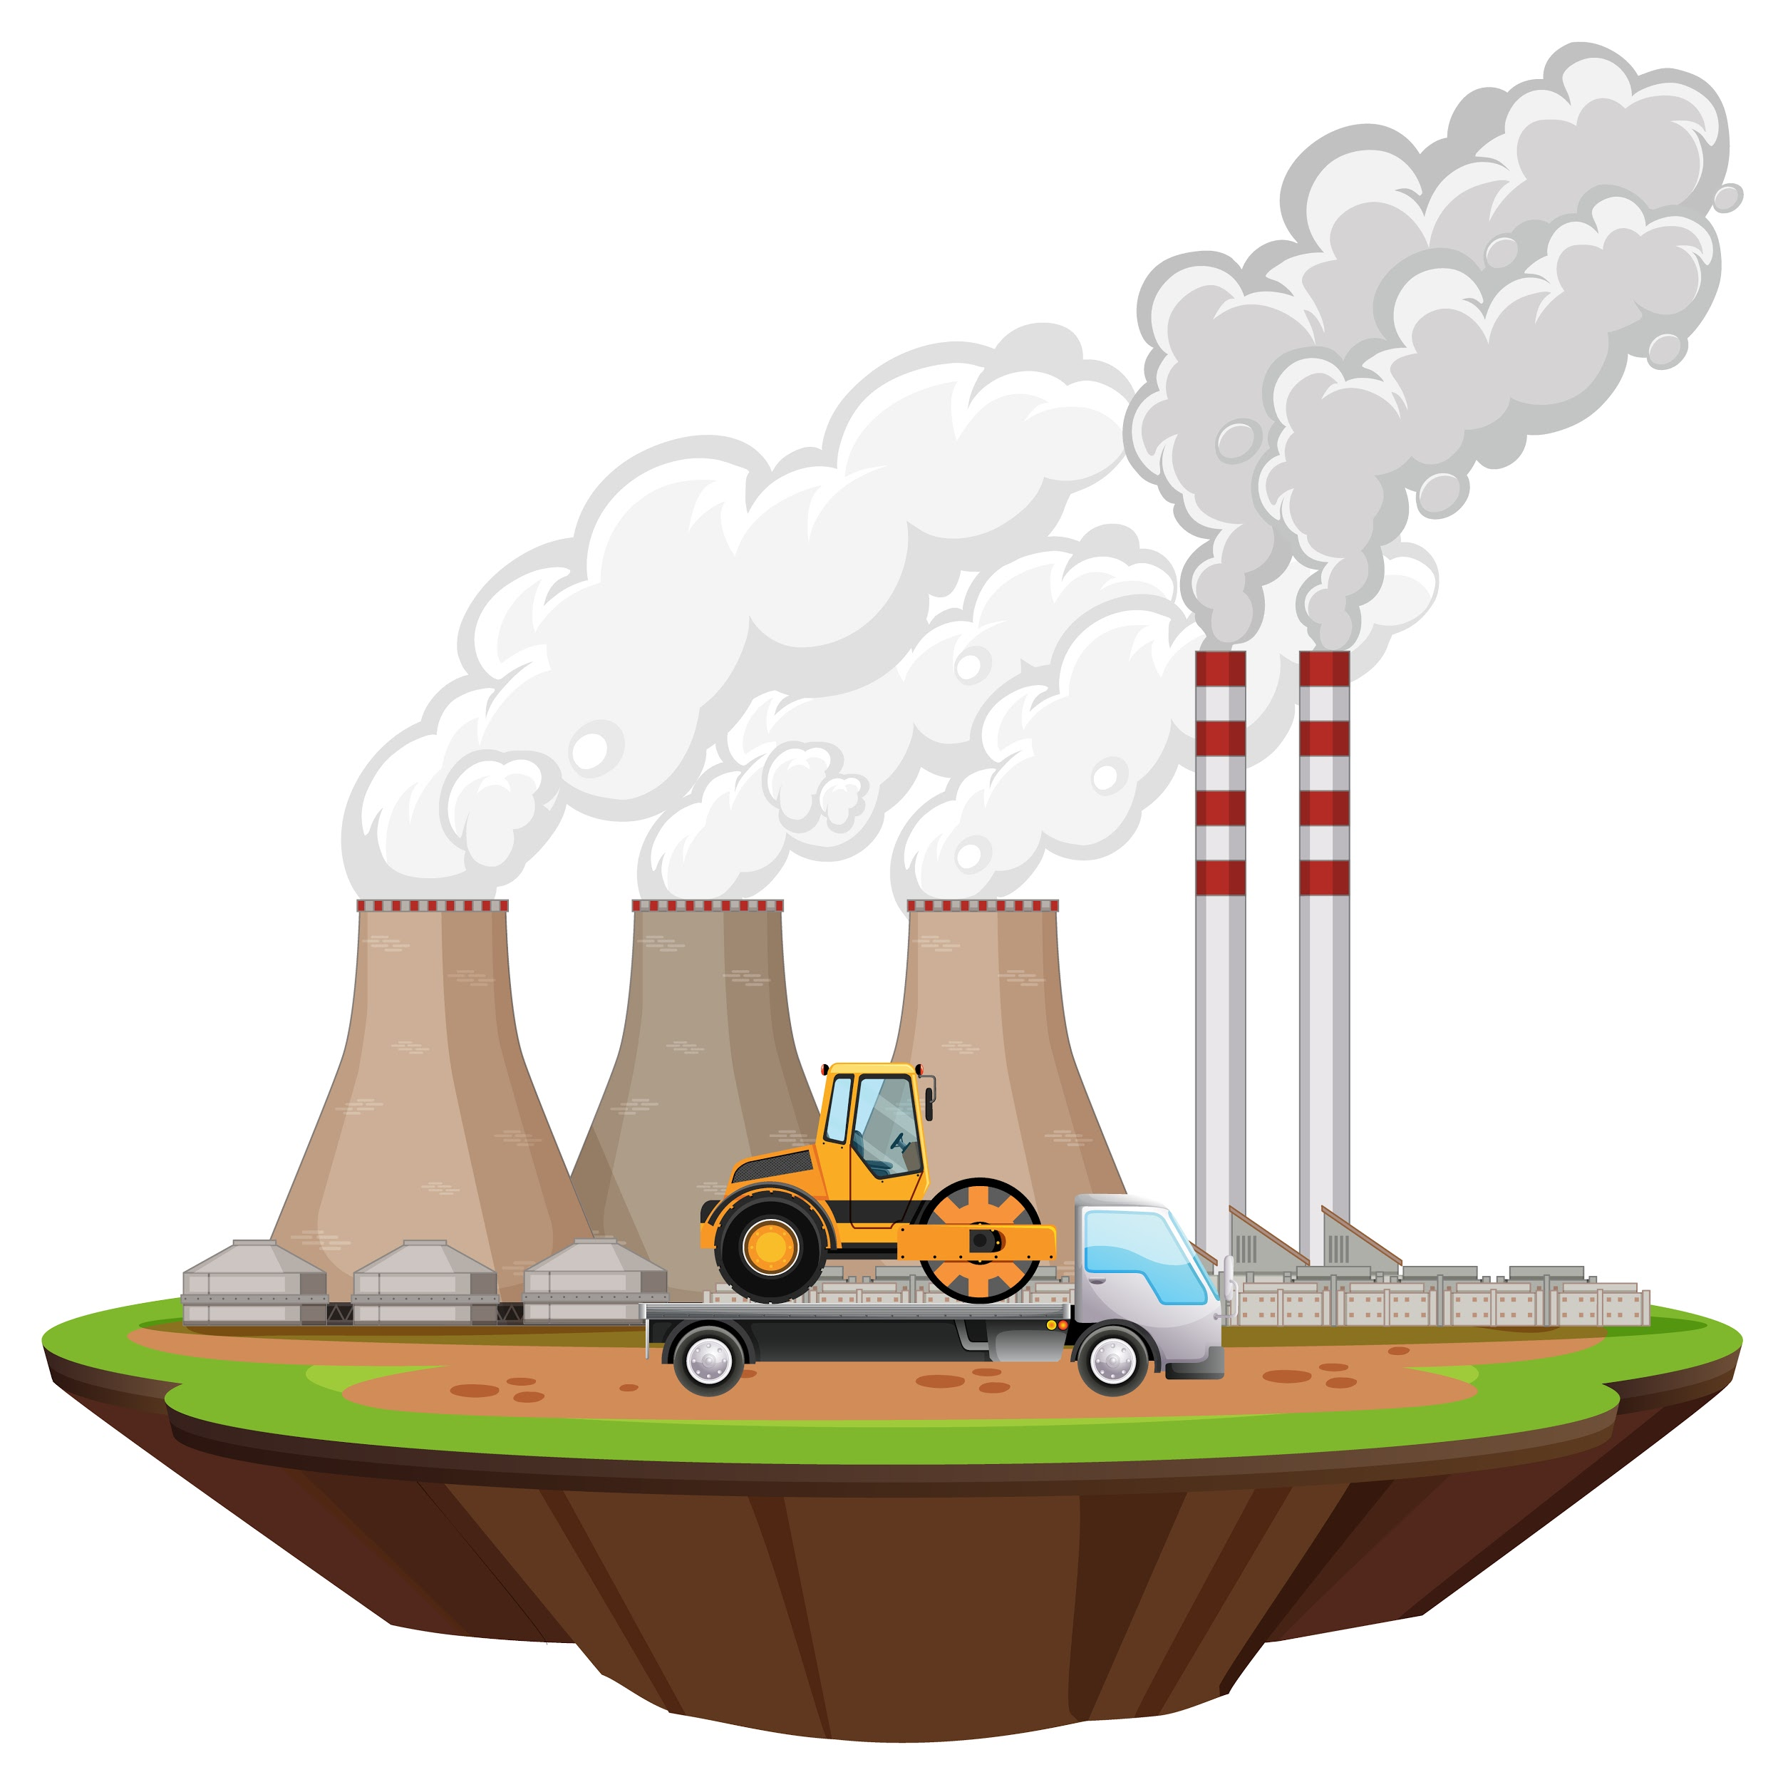
My name is Amy and today I gave a talk on global warming. I had been wanting to speak about this topic for several years as it’s something I feel very passionate about. I presented the statistics of various factors such as pollution, rising sea levels etc and I feel like this helped give credibility to what I was saying. I had butterflies in my stomach as I went in but as I left the stage I felt invincible! I hope that the presentation made a difference.
The response was fantastic. Everyone was saying what a good job I did and some even wanted to do more talks. So, now I have two more talks to give this week and now that I’ve done the first one, it should all be downhill from here (I hope!)

I. Exercise one - Fill in the blanks

1. My name is __________________________________.
a. Andy
b. Amish
c. Alan
d. Amy

2. I had __________________________________ in my stomach
a. butterflies
b. caterpillars
c. bees
d. spiders

3 .So, now I have __________________________________ more talks to give this week
a. one
b. two
c. three
d. four

II. Exercise two - Answer the questions

1. What did Amy speak about?

________________________________________________________________

2. How long had she wanted to speak about this topic?

________________________________________________________________

3. What is some of the information she spoke about?

________________________________________________________________

4. How did she feel when she started the presentation?

________________________________________________________________

5. How did she feel when she finished the presentation?

________________________________________________________________

III. Exercise three - Talk about yourself

1. Do you think global warming is real?
____________________________________________________________________________

____________________________________________________________________________

2. What can be done to combat global warming?
____________________________________________________________________________

____________________________________________________________________________

3. Do you do anything to fight global warming?
____________________________________________________________________________

____________________________________________________________________________

This is a free worksheet for your ESL lessons from
JIMMYESL.com
………...
Get more free resources here
https://jimmyesl.com/esl-teacher-resources/
…………
For questions, comments or just to say “thank you”,
send an email to ESL Teacher Jon Race at
jon@team.jimmyesl.com

Simply print out this worksheet
without the last page
for your lessons.

