Going on holiday

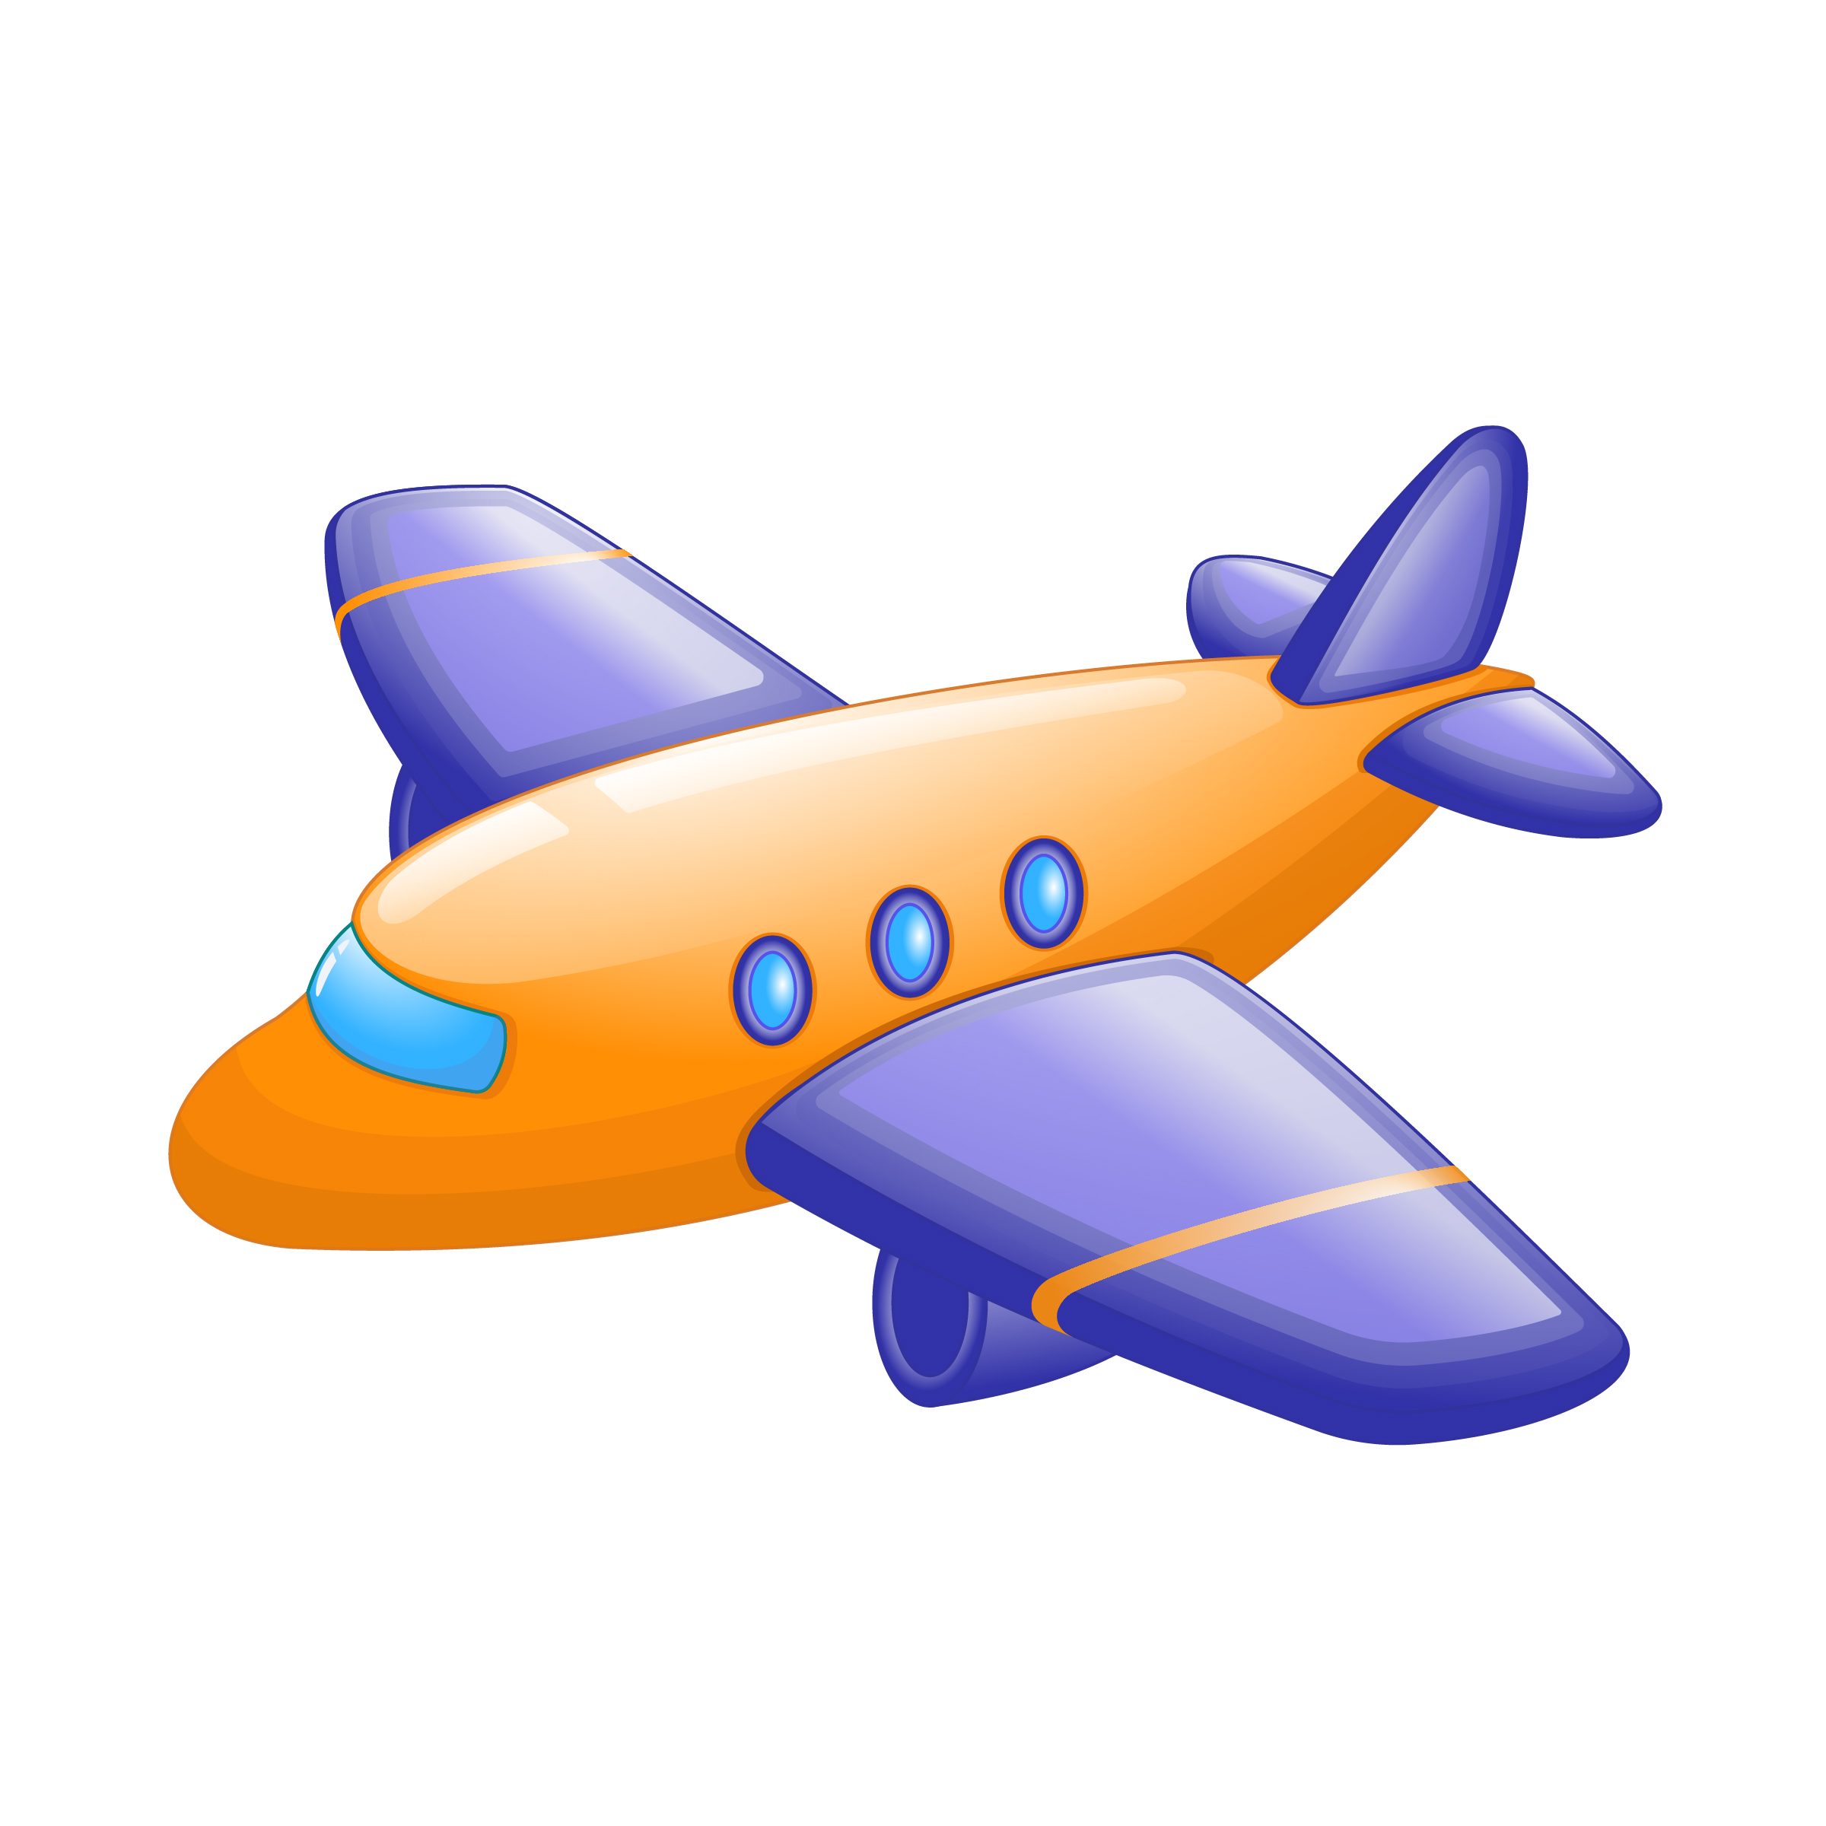
My name is Jane and I want to go on holiday to somewhere exciting, somewhere fun and with lots of people. Last year I went to Spain for two weeks. I went with my parents and a few of my friends from school. My brother wanted to go to Germany but I’m glad we went to Spain, it’s much better! If I could choose somewhere this year then I would go to Switzerland. I could go skiing and snowboarding and even have a snowball fight with my dad! I’ve been skiing before but it was only for a day. If I went on holiday then I could ski all week.

I. Exercise one - Fill in the blanks

1. Last year I went to __________________________________ for two weeks.
a. America
b. Germany
c. Spain
d. France

2. I could go __________________________________ and snowboarding
a. skiing
b. running
c. dancing
d. fishing

3 .If I went on holiday then I could __________________________________ all week.
a. sleep
b. sing
c. ski
d. surf

II. Exercise two - Answer the questions

1. Where did Jane go on holiday last year?

________________________________________________________________

2. Where does she want to go this year?

________________________________________________________________

3. What would Jane do if she went to Switzerland?

________________________________________________________________

4. Does Jane have a brother or a sister?

________________________________________________________________

5. Does Jane prefer holidays that are relaxing or exciting?

________________________________________________________________

III. Exercise three - Talk about yourself

1. Where did you last go on holiday?
____________________________________________________________________________

____________________________________________________________________________

2. What do you need to take with you on holiday?
____________________________________________________________________________

____________________________________________________________________________

3. Where would you like to go on holiday?
____________________________________________________________________________

____________________________________________________________________________

This is a free worksheet for your ESL lessons from
JIMMYESL.com
………...
Get more free resources here
https://jimmyesl.com/esl-teacher-resources/
…………
For questions, comments or just to say “thank you”,
send an email to ESL Teacher Jon Race at
jon@team.jimmyesl.com

Simply print out this worksheet
without the last page
for your lessons.

