Visiting a restaurant

Hi, I’m Tim and my favourite food is pizza. I went to a restaurant yesterday and ate so much food! I went with my friend Mary. She is currently working at that restaurant so we didn’t have to pay! It was my first time in this restaurant and I really enjoyed it. Afterwards, we got a drink and then went home.
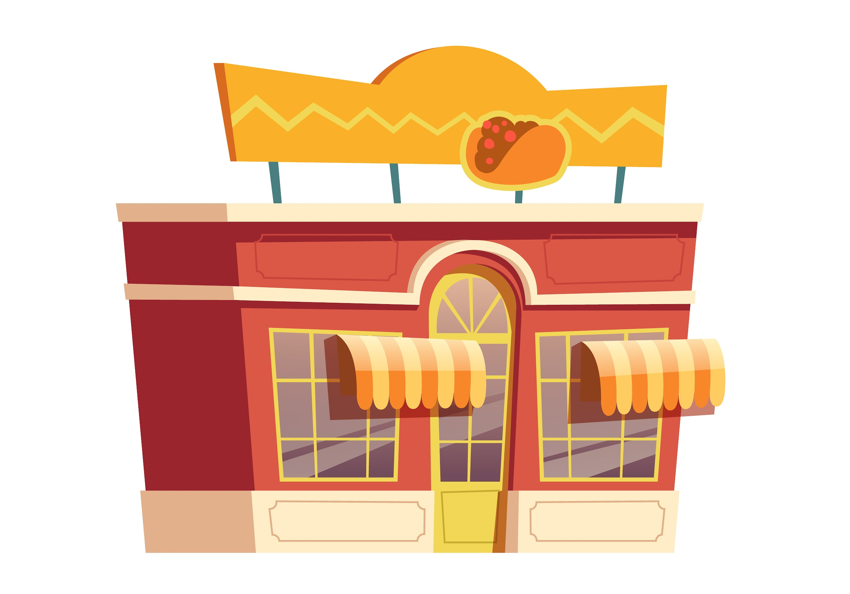

I. Exercise one - Fill in the blanks

1. Hi, I’m __________________________________
a. Tom
b. Dave
c. Tim
d. Dom

2. I went to a __________________________________ yesterday
a. cafe
b. cinema
c. shop
d. restaurant

3. I went with my __________________________________ Mary.
a. mum
b. friend
c. sister
d. dad

II. Exercise two - Answer the questions

1. What is Tim’s favourite food?

________________________________________________________________

2. Where did Tim go yesterday?

________________________________________________________________

3. Who did Tim go with?

________________________________________________________________

4. What is Mary’s job?

________________________________________________________________

5. What did they do after the restaurant?

________________________________________________________________

III. Exercise three - Talk about yourself

1. What’s your favourite restaurant?
____________________________________________________________________________

____________________________________________________________________________

2. Would you like to work in a restaurant?
____________________________________________________________________________

____________________________________________________________________________

3. What’s your favourite food?
____________________________________________________________________________

____________________________________________________________________________

This is a free worksheet for your ESL lessons from
JIMMYESL.com
………...
Get more free resources here
https://jimmyesl.com/esl-teacher-resources/
…………
For questions, comments or just to say “thank you”,
send an email to ESL Teacher Jon Race at
jon@team.jimmyesl.com

Simply print out this worksheet
without the last page
for your lessons.

