Sarah goes to the zoo

Sarah is David’s friend. They went to the zoo and saw a monkey and a lion. The weather was sunny. David bought ice cream for Sarah. Later, it rained so they went home. Then, they ate chips.

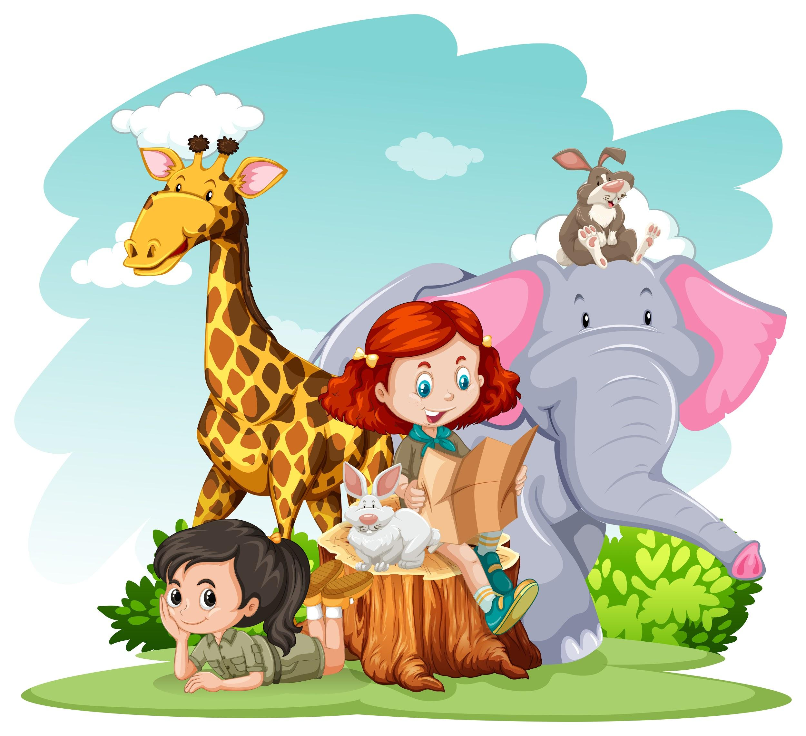

I. Exercise one - Fill in the blanks

1. Sarah is David’s __________________________________.
a. mum
b. friend
c. sister
d. dad

2. They went to the __________________________________
a. zoo
b. cinema
c. park
d. library

3. David bought __________________________________ for Sarah.
a. chocolate
b. flowers
C. ice cream
d. crisps

II. Exercise two - Answer the questions

1. Who is Sarah?

________________________________________________________________

2. Where did Sarah and David go?

________________________________________________________________

3. What did they see?

________________________________________________________________

4. What was the weather like?

________________________________________________________________

5. What did David buy?

________________________________________________________________

III. Exercise three - Talk about yourself

1. What is your favourite animal?
____________________________________________________________________________

____________________________________________________________________________

2. Do you like zoos?
____________________________________________________________________________

____________________________________________________________________________

3. What other animals are at a zoo?
____________________________________________________________________________

____________________________________________________________________________

This is a free worksheet for your ESL lessons from
JIMMYESL.com
………...
Get more free resources here
https://jimmyesl.com/esl-teacher-resources/
…………
For questions, comments or just to say “thank you”,
send an email to ESL Teacher Jon Race at
jon@team.jimmyesl.com

Simply print out this worksheet
without the last page
for your lessons.

