Ben loves to play football

Hello, my name is Ben. I am 10 and I have a brother. I like bread and milk. Today, I played football in the park. I have a dog, its name is Tony. Tony sometimes plays football with me. It was sunny and I like sunny weather. Later, I was tired, so I went home.

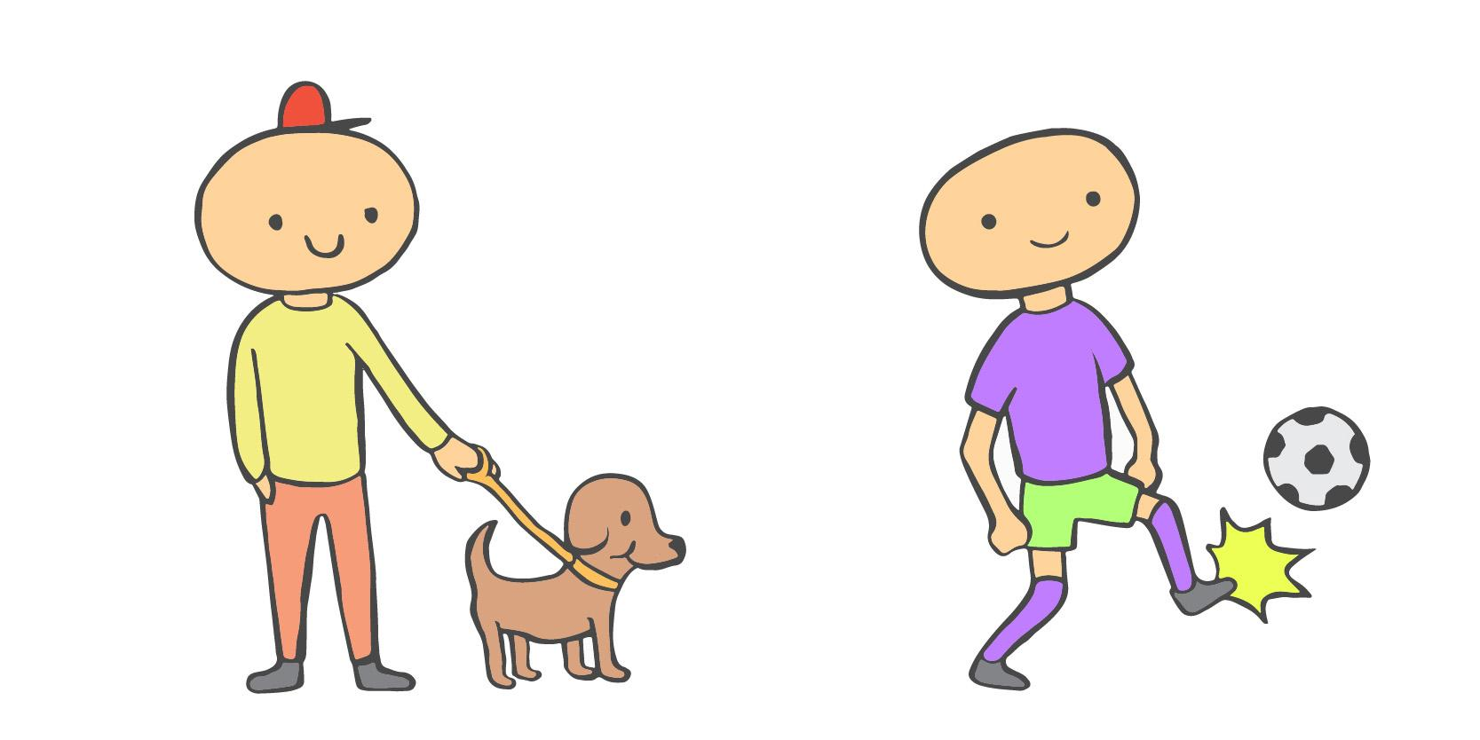

I. Exercise one - Fill in the blanks

1. Hello, my name is __________________________________.
a. Ben
b. Bill
c. Bob
d. Brendan

2. Today, I played __________________________________ in the park.
a. tennis
b. rugby
c. football
d. cricket

3. Later, I was tired, so I went __________________________________.
a. to sleep
b. to the park
c. to the shop
d. home

II. Exercise two - Answer the questions

1. How old is Ben?

________________________________________________________________

2. Does Ben have a brother or a sister?

________________________________________________________________

3. What food does Ben like?

________________________________________________________________

4. What did Ben do at the park?

________________________________________________________________

5. What is Ben’s Dog called?

________________________________________________________________

III. Exercise three - Talk about yourself

1. Do you like to play football?
____________________________________________________________________________

____________________________________________________________________________

2. Say which food you like.
____________________________________________________________________________

____________________________________________________________________________

3. Do you have a pet?
____________________________________________________________________________

____________________________________________________________________________

This is a free worksheet for your ESL lessons from
JIMMYESL.com
………...
Get more free resources here
https://jimmyesl.com/esl-teacher-resources/
…………
For questions, comments or just to say “thank you”,
send an email to ESL Teacher Jon Race at
jon@team.jimmyesl.com

Simply print out this worksheet
without the last page
for your lessons.

